Lab 11
Introduction
In operating systems, memory allocation is a critical task. When processes request memory dynamically, the OS must decide where in memory to place each process. Poor allocation strategies can lead to external fragmentation, small, unusable gaps in memory.
Three common memory allocation strategies are:
- First Fit: Allocate the first block that is large enough. (Provided)
- Best Fit: Allocate the smallest block that is large enough.
- Worst Fit: Allocate the largest block available.
The goal of this lab exercise is to:
- Implement Best Fit and Worst Fit algorithms.
- Compare the resulting memory fragmentation for a given workload.
- Analyze trade-offs between these strategies.
Algorithm Explanations
  - Best Fit
Logic:
- For each process, search the entire list of free memory blocks.
- Select the block that is large enough for the process and leaves the smallest leftover fragment.
- If multiple blocks are equally good, choose the first one found.
Advantages:
- Minimizes wasted space in individual blocks.
- Can be efficient for small processes.
Disadvantages:
- May create many tiny fragments that cannot be used for future processes.
- Searching all blocks can be slower.
  - Worst Fit
Logic:
- For each process, search the entire list of free memory blocks.
- Select the block that is large enough and leaves the largest leftover fragment.
- If multiple blocks are equally large, choose the first one found.
Advantages:
- Keeps large blocks free for future processes.
- Can reduce the chance of small, unusable fragments.
Disadvantages:
- May waste memory unnecessarily by leaving very large fragments unused for small processes.
Best Fit:
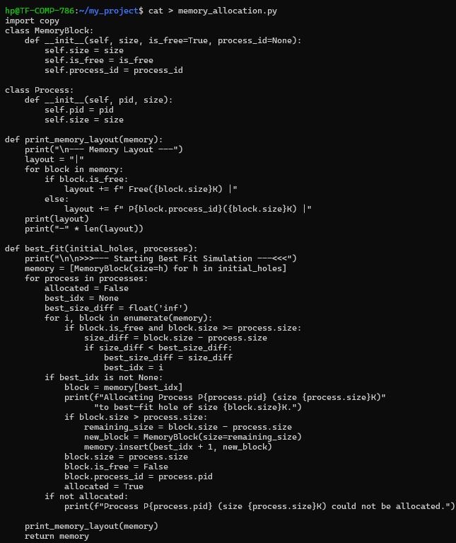

Worst Fit
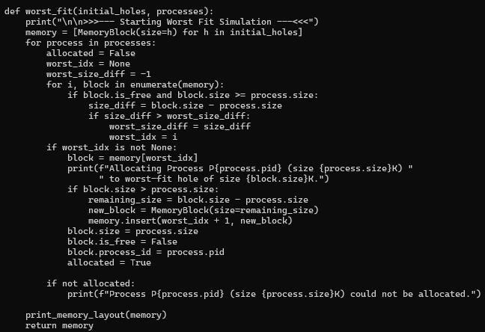
First Fit
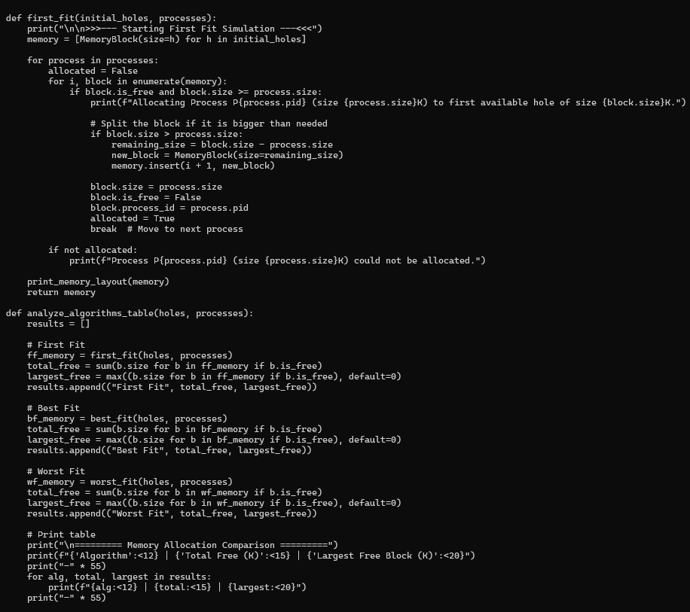
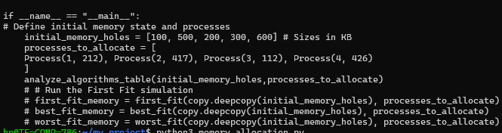
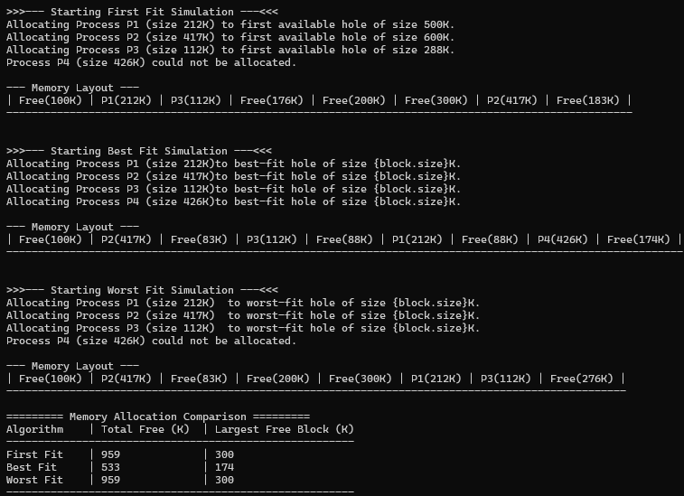

Key Observations:
- Best Fit reduces leftover space in individual blocks but can create many small unusable fragments (external fragmentation).
- Worst Fit preserves large contiguous blocks, which can be useful for future large processes, but may waste memory for small processes.
- Trade-off: Best Fit → efficient for minimizing immediate waste, Worst Fit → efficient for long-term large block availability.
Conclusion
- Most successful at preserving large contiguous blocks: Worst Fit, because it leaves larger holes for future allocations.
- Most external fragmentation: Best Fit, due to many small leftover fragments.
- Primary trade-off:
  - Best Fit: minimizes waste in each allocation but can fragment memory overall.
  - Worst Fit: reduces fragmentation for large processes but may waste memory on small allocations.

